CS5551 Advanced Software Engineering

Lab Assignment 1 Report

Name: Anh T Nguyen

ID: 19

Email: lndhf@mail.umkc.edu

Github link: <https://github.com/anhnguyent93/CS5551/tree/master/Lab1>

# Requirements

# Install softwares and technologies.

# Github, Zenhub Plugin, Github Desktop

# 

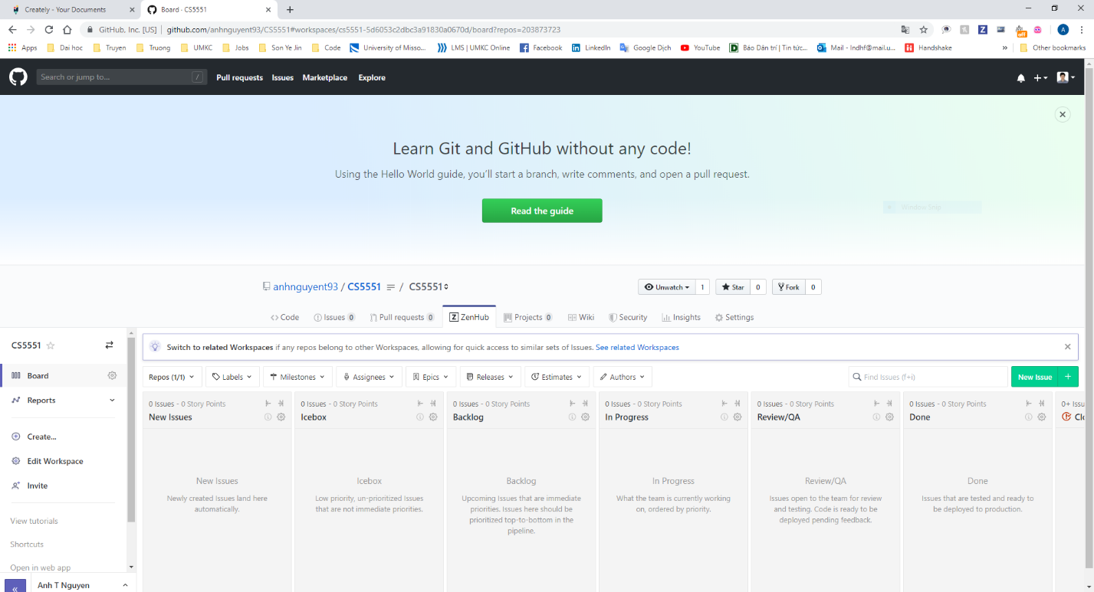

# Brackets, Webstorms

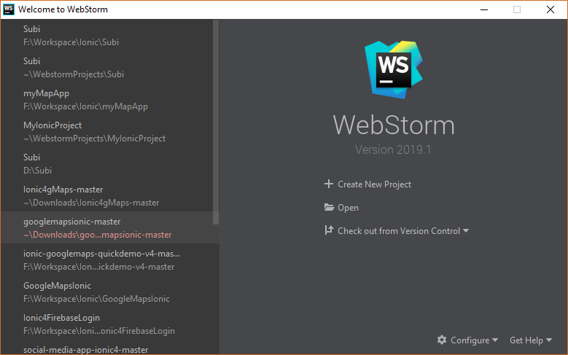

# 

# Ionic CLI, NodeJS, NPM

